Notes of Grace-Happy New Year
January 3, 2026 – January 4, 2026
Praising God + Serving Others + Building Relationships + Growing Faith

Wherever you are in your faith journey, we welcome you to worship today. If you are interested in finding out more about being a member of Grace, please let Pastor Julie know. We invite visitors to fill out our guest book in the entryway.

Reminder – GLOW and Confirmation will resume Wednesday, January 7, 2026.
Thank You
As we wrap up 2025, I want to thank the congregation members of Grace for your thoughtfulness and generosity this holiday season. Your kind words and support mean so much to my husband Mike and I. It is a blessing to be part of this Grace family and I look forward to sharing ministry with all of you in 2026.
May the New Year be healthy and happy for you and yours,
Pastor Julie

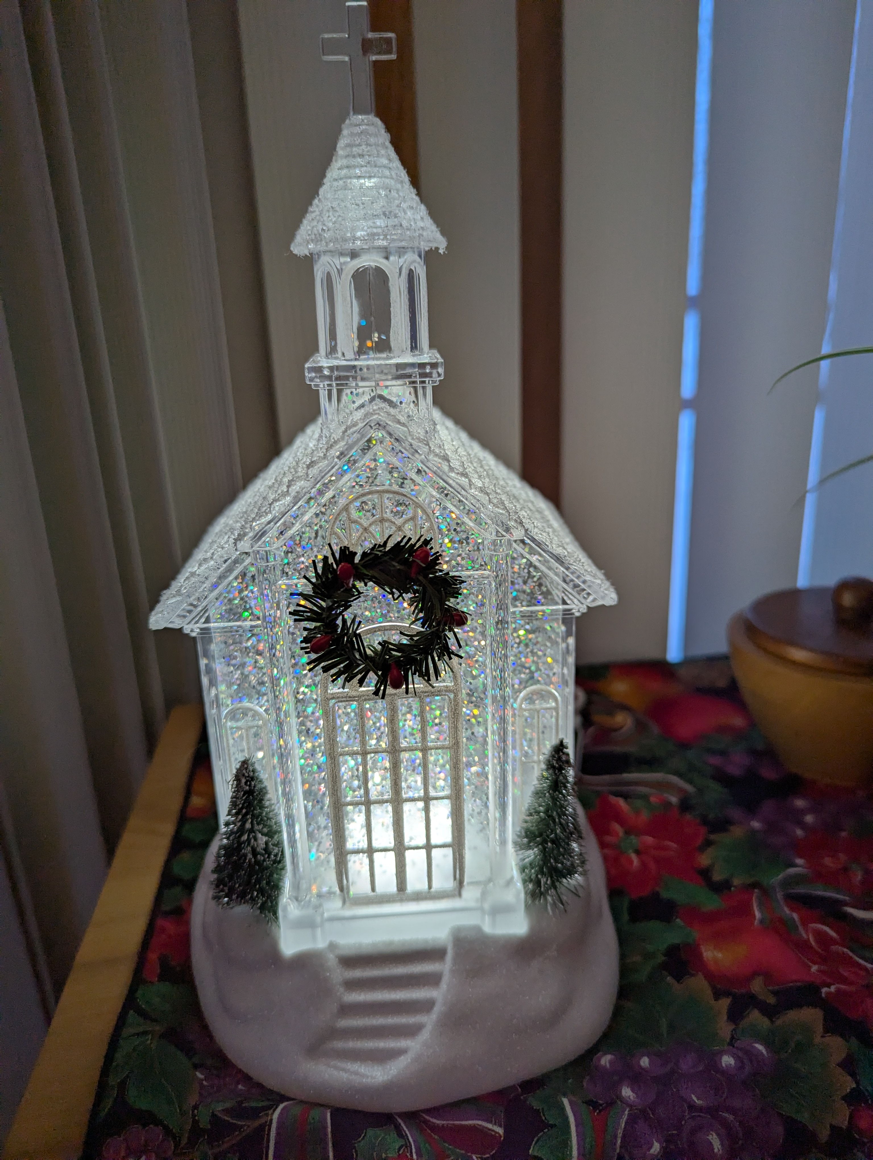

Last week’s altar flowers were donated anonymously for God and all God does for us!
Blessings for Babies Diaper Ministry in need of size 4 and 6 diapers. If you are interested in helping with this ministry sign up in the Gathering Area. Thank you.
Diaper bank hours: 2nd and 4th Monday of the month. Time: 3:30 pm – 5:30 pm

Lasagna and Dessert Cook off Fundraiser for the Wilderness Group The wilderness group will be hosting a Lasagna and Dessert Cook off on January 25th at Noon. Please sign up in the Gathering Area starting in January to bring a lasagna, or dessert. If you sign up to bring a food item to enter the competition, you do not need to purchase a ticket. To vote on the best lasagna and dessert, purchase your tickets in the month of January for $20. Top two winners in each category will win prizes!

JANUARY SPECIAL OFFERING – Frederick Place
Frederick Place in Rhinelander, WI is a 16-bed emergency, temporary shelter for families, women and men who are experiencing homelessness. It is operated by The Northwood’s Alliance for Temporary Housing Inc. (NATH), which is a not-for-profit corporation. Frederick Place is committed to ending and preventing homelessness. Along with NATH, they exist to provide safe housing and basic needs to families and individuals who are experiencing homelessness, within an atmosphere of encouragement, respect, dignity, and hope; while nurturing and promoting self-sufficiency and independence. Frederick Place opened its doors on January 31, 2011 and has never been empty.

Annual Meeting Date—January 25, 2026 The Annual Meeting of Grace Lutheran Church will take place on January 25, 2026. It will begin at approximately 10am (following the 9am worship service). There will be a ZOOM option for anyone who is not available in person. If you need the zoom link, let Barb or Mary know in the office 715-453-4066. Committee report deadline: January 9.

Indoor Worship Assistants
January 10 – January 11

Saturday 5:00 pm
Readers: Carey Heikkinen
Ushers: Brett Beaumier
Communion Assistants: Carey Heikkinen
Running Projection: Jen Beaumier

Sunday 9:00 am
Reader: Jordy & Keri Kelley
Ushers: Dar & Sherry Clements
Communion Assistant: Vicki Stromberg & Gail Wilson
Running Projection: Karen Torkelson
Projection Set-Up: Karen Torkelson
Live Stream: Savannah Reinke
January 5 – January 11 Weekly Events

Monday, January 5
5:00 pm – Knitter’s Group

Tuesday, January 6
8:00 am – PPP Guys
9:00 am – Quilters

Wednesday, January 7
3:30 pm – GLOW
6:30 pm - Confirmation

Thursday, January 8

Friday, January 9
Annual Report Deadline
Office Hours 8 am – 1:00 pm

Saturday, January 10
9:00 am – AA/Alanon
5:00 pm – Worship Service

Sunday, January 11
8:45 am Grace Kids
9:00 am – Worship Service

Prayer List
Heidi Anderson (Jeff Fossum)
Michelle Anderson (Brenda Marcks)
Elaine Dabler (Cassady Grabow-Hohensee)
Ava Dvorak (Nicholas & Sarah Dvorak)
Michelle Fox (Peggy Price)
Nancy Heise (Dorothy Kind)
Devin Hess (Renee Loka)
Shawn Hipler (Jeff Niewinski)
To the family of Jerry Jach (Fritz Jach)
Vicky Jach
Becki Marchand (Pat & Sandy Granrath)
Donna Olson (Paul Zastrow)
Charlotte Parker (Karen & Mike Kahle)
Roger Schlegel
Jackie Strebe (Jim & Jan Van Norman)
Kerry Stevenson (Jeff Niewinski)
Duane Strauss (Irene Strauss)
Darlene Weirick

MILITARY LIST:
Christian Colburn, Sebastien Thayer, Dylan Ellison, Drew Hohensee, Tyler Horst, Michael LaFevre, Jessica Olejar, James Torgerson Jr, Charlie Richards, Mason Talaga, Jeff VanStrydonk, Henry Wessel, David Halverson, Jenna Meal

Prayer List Requests: To add someone to the prayer list, call the Grace office at (715) 453-4066 or fill out a Prayer Request form in the lobby by the guest book.

Merry Christmas and Thank you from Our Sister’s House:
To Everyone at Grace Lutheran Church,
Thank you so much for your special offering donation and all of your support for Our Sister’s House Shelter over the past year.
We couldn’t do our work without our community and you are part of what makes Tomahawk special!
Have a wonderful Holiday Season.
Thank you,
Margaret Heykes
Director, OSH



The Red Cross Blood Drive at Grace January 13. Kick off 2026 with a blood donation!
When you come to give with the Red Cross Jan. 1-25, you'll automatically get a chance to score a getaway to Super Bowl LX in California. Schedule your appointment today to give during the Tomahawk Blood Drive at Grace Lutheran Church on Tuesday, January 13th. Donors can sign up by going to www.redcross blood.org, use the Blood Donor app or call 1 800 RED CROSS (1 800 733-2767). The collection goal for our blood drive is 62 pints, we were able to collect 49 pints during the blood drive in November.

Offering: Mail, bring to church or give online; one-time contribution or set up auto giving through Vanco. Go to our website: www.gracelutherantomahawk.com under Announcements, click on, GIVING TO GRACE WITH VANCO.

