

**April Weekly Events**

**Monday, April 8**

5:00 pm Men’s Bible Study & Pastor Susan’s Knitting Group

**Tuesday, April 9**

9:00 am Quilters

9:30 am Visitation for Don Christian

11:00 am Don Christian Celebration of Life

**Wednesday, April 10**

9:00 am Four Rivers Quilters

3:30 pm Glow-Seder Meal

6:30 pm Confirmation

**Thursday, April 11**

6:00 pm Church Council

**Friday, April 12**

Office Closed

**Saturday, April 13**

9:00 am AA/Alanon

5:00 Worship Service

**Sunday, April 14**

9:00 am Worship Service

10:15 am Sunday School

***Our Prayers and Sympathy*** go out to Pastor Susan & the family of Don Christian. Don passed away April 1. May they be comforted with hope of eternal life. His Celebration of Life will be held Tuesday, April 9 at Grace: Visitation 9:30-11am & Funeral 11am with a luncheon to follow.

***Volunteers Needed for***

**Sunday Fellowship**

Provide fellowship and delicious treats after Sunday worship services this spring! The church purchases the treats. Sign-up in the Gathering Area.

**Welcome to Grace Lutheran Church!**

Wherever you are in your faith journey, we welcome you to worship today! If you are interested in finding out more about being a member of Grace, please let Pastor Julie know. We invite you to fill out our guest book in the entryway.

**Praising God + Serving Others + Building Relationships + Growing Faith**

**Soup Lenten Suppers** - I would like to thank everyone that helped with serving & providing meals for the Lenten suppers. We had 46 people who donated & volunteered to serve in the kitchen. Together we had 333 people with an average of 56 people/week attend. The fellowship shared was priceless. With this we also raised $205 for the youth to attend the EYG. We also raised $685 toward fixing up the Grace House which is another important mission of our congregation for the outreach in the Tomahawk community. Thank you to all of you who helped out. I am very blessed to be a part of this ministry. ~Margie Welke

**Men’s breakfast and prayer group** meets weekly Fridays at 7 am at the Tomahawk Family Restaraunt. While sharing a meal, stories and laughter they also discuss the old and new testament readings and gospel. All are welcome. Just drop in.

**Thank you** to all the wonderful volunteers who helped make Holy Week services possible!

### ***OFFERING****:* Mail, bring to church or give online: one-time contribution or set up auto giving through Vanco. Go to our website: [www.gracelutherantomahawk.com](http://www.gracelutherantomahawk.com). Under Announcements, click on, GIVING TO GRACE WITH VANCO.

**Where do we see God at work?**

To everyone at Grace Lutheran Church. Thank you very much for choosing Our Sister’s House as an endowment recipient. We are very grateful for your generosity and appreciate all the support you’ve given us at OSH. Thank you for all you do for our community! Massie Heykes, Executive Director.

**New Video Screens Are Ordered!**

Amazing news! In December, we added a project to our Gift Catalog to replace our projection screens in the sanctuary. By mid-March, over $25,000 had been given for the screens-and they have been ordered! Planning for the electrical and video cabling work has already begun. THANK YOU to all who have helped this project become a reality in such a short time! We are so blessed!

**Joyful Noise Luncheon**

Tuesday, May 14, 2024 @ 11:30am

Loop Hole Bar & Grill 2243 County Rd L

***EYG Number Board fundraiser located in the Gathering Area is another way to help support our youth attending the EYG gathering in New Orleans.***

**Special Offering for April: Synod Assembly Service Project for Crossways Camps. More information to come. Synod Assembly is May 17 & 18.**

**Prayer List**

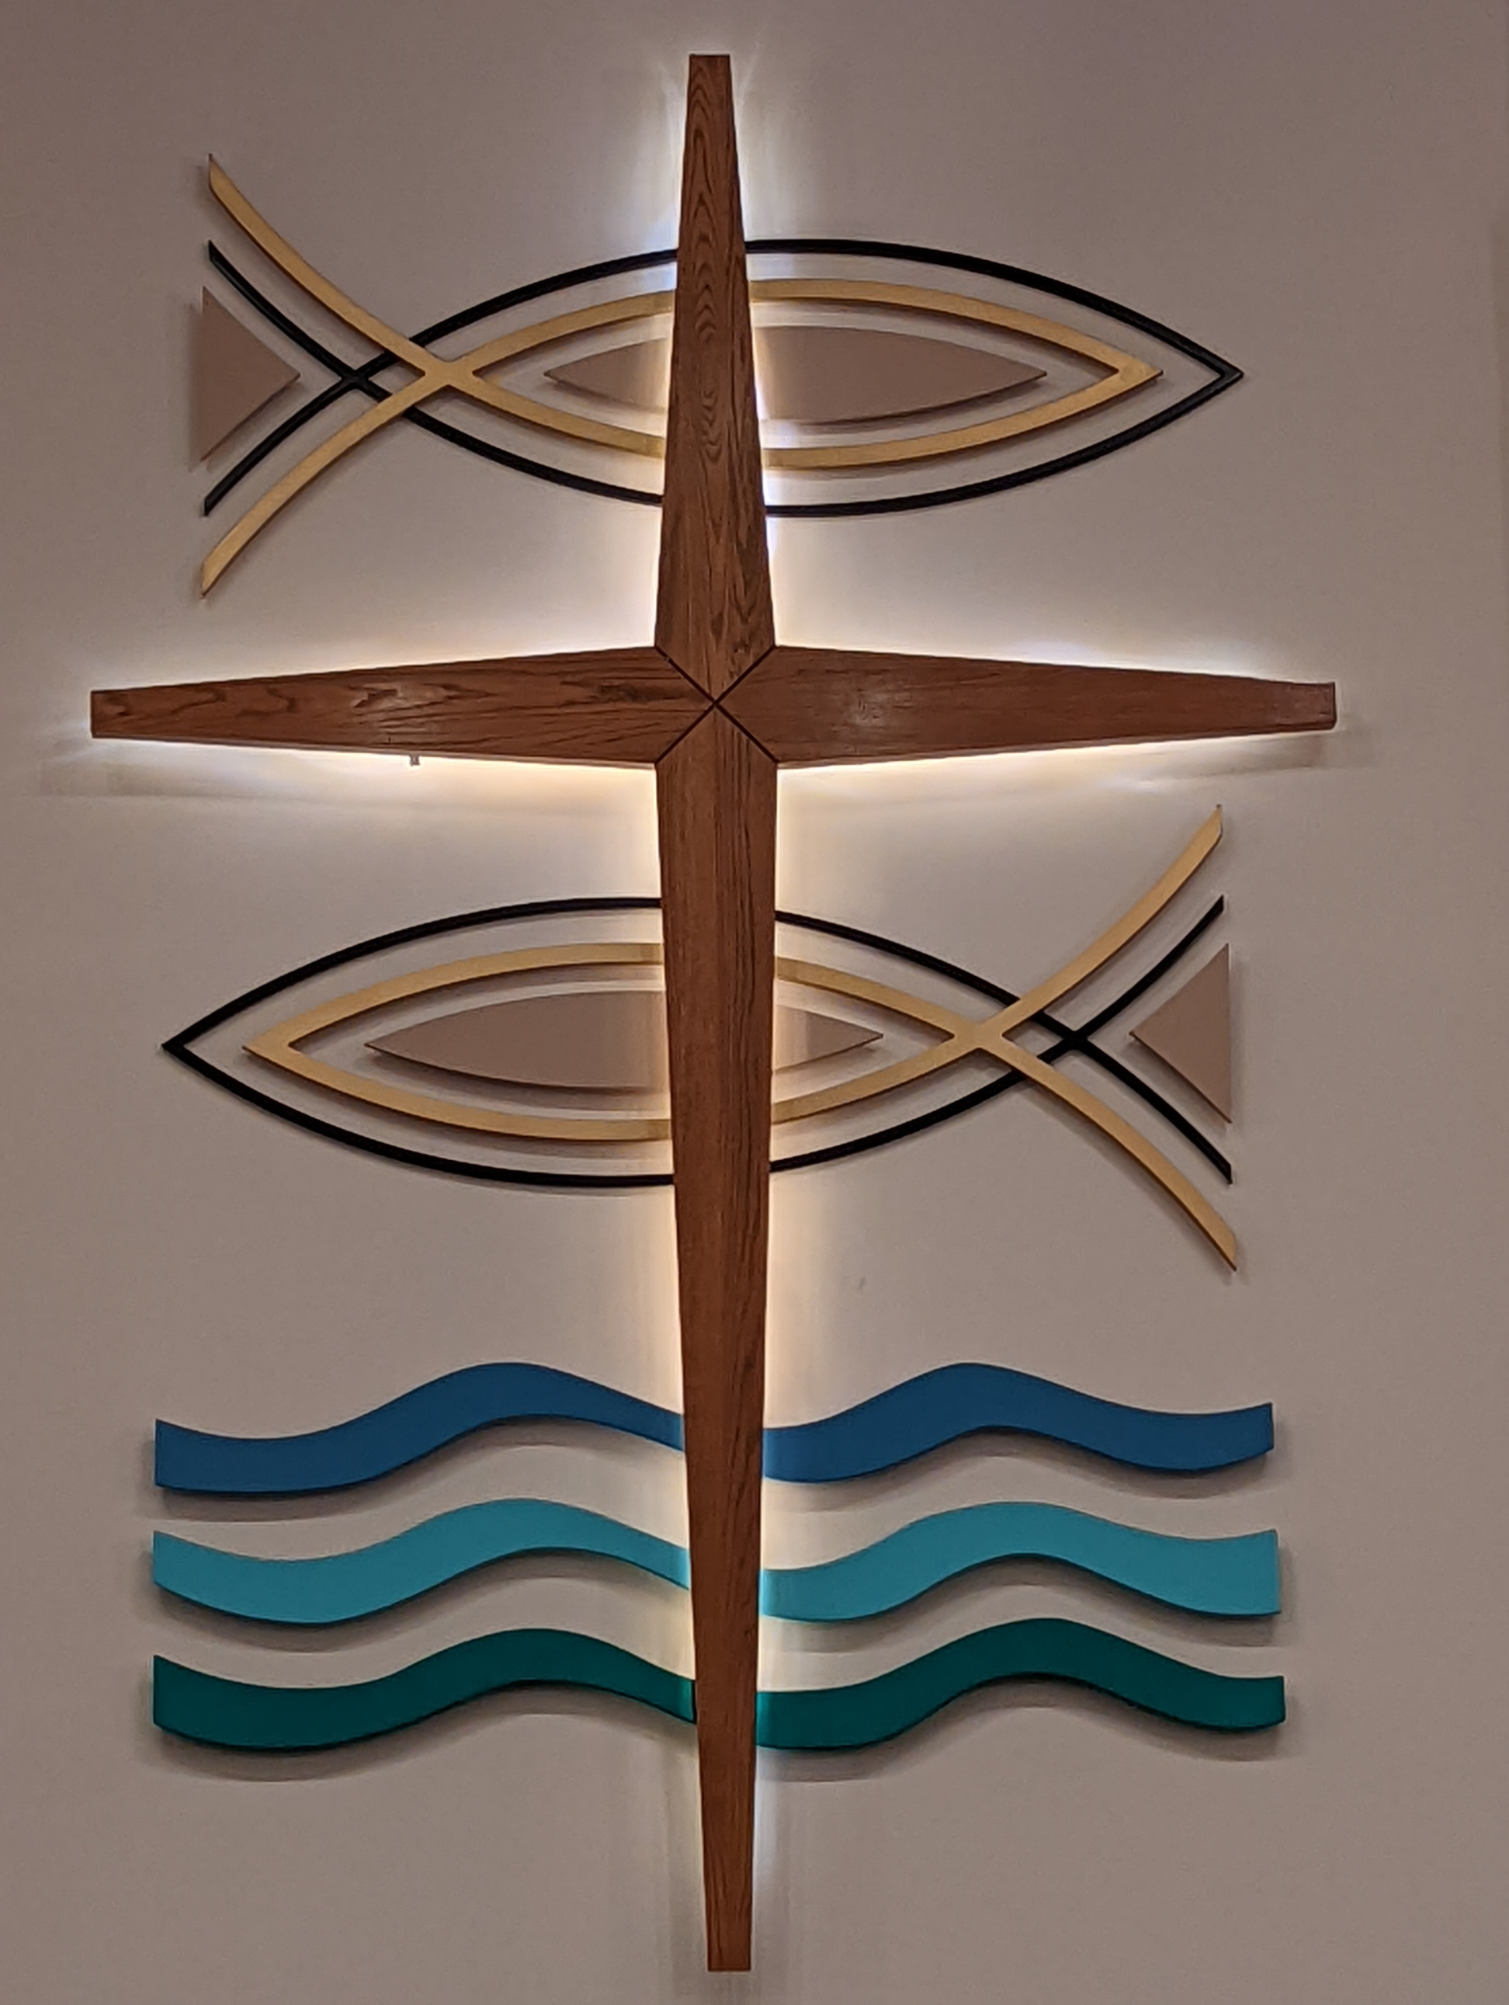

Arabindo (Pastor Julie’s friend)

**Melody Barger** (Pastor Julie’s family member)

Cathy Bilanski

Janet Brown (Joe Story)

Jane Bushor (niece of Darlene Weirick)

John Case (Sue Mielke’s brother-in-law)

Don Christian

Archie Crohn (Tami Olson’s mom)

Kelly Derlein (Pastor Julie’s friend)

David Erickson

**Jack & Cheryl Evans**

Sandy Granrath (Pat Granrath)

Lindsey Johnson (Nancy Herbison’s nephew’s wife)

Ruth Johnson (Nancy Herbison’s mom)

Mark Lock (Al Raatz)

Kat Mosher (Judy Bye)

**Deb Narloch**

Michael Pertmer

Bob Radley (brother of Darlene Weirick)

Stacy Schiltz (daughter of Bill and Barb Schiltz)

Bill Strand

Leon Stuewer (Dottie Anderson’s brother-in-law)

Susie (relative of Lori Brandt)

David Tinker (Deb & Don Tinker)

Jim Torgerson

Dawn Vanhoof (Irene Strauss’ friend)

Paulette Warner (Peggy Price’s sister)

**MILITARY LIST**

Sebastien Thayer

Dylan Ellison

Tyler Horst

Michael LaFevre

James Torgerson Jr

Charlie Richards

Jeff VanStrydonk

**Prayer List Requests:**

**If you would like to add someone to the prayer list, please call the office at (715) 453-4066 or fill out a prayer request form in the lobby by the guest book.**

***NURSING HOMES & HOMEBOUND***

***Country Terrace***

Bertie Wurl

Edythe Mielke

Jeanette Lovsletten

Betty Hudson

Don Habeck

***Tomahawk Health Services***

Richard Collins

***Riverview Health Services***

***Milestone Senior Living***

***Tomahawk & Rhinelander***

Janette Kurth Tomahawk

Fran Anderson Tomahawk

Nancy Bronsted Tomahawk

Sherry Thompson Tomahawk

Dorothy Kind Tomahawk

LaRay Norlin Tomahawk

Don Paulson Tomahawk

**Notes of Grace**

**April 6 & 7, 2024**

**Grace Lutheran Church**

**108 W Somo Ave.**

**Tomahawk, WI 54487**

**(715) 453-4066**

**If you can’t attend worship, we can come to you! See link for streaming services.**

[**www.gracelutherantomahawk.com**](http://www.gracelutherantomahawk.com)

**CONTACT US:**

Office Phone: (715) 453-4066

Office Hours: Monday-Thursday 8am-1pm

[gracetomahawkoffice@gmail.com](mailto:gracetomahawkoffice@gmail.com)

Pastor Julie Barger Sinkula

Office Hours: Mon, Tues, Thurs, 9am-noon

Wed. 12:30pm-3:30pm

By Appointment:

(715) 216-7652 mobile

pastorjuliebarger@gmail.com

Visitation Pastor Kathryn Tulman

(715) 579-6780 mobile

Ktulman2020@gmail.com